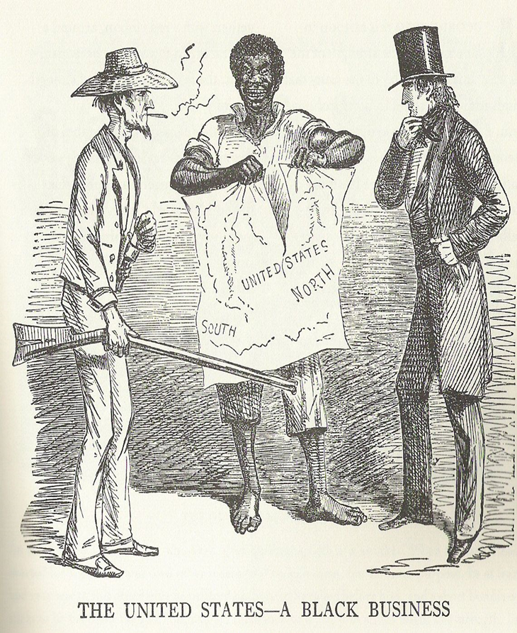 | This cartoon, taken from the London newspaper Punch, not only shows what was going on in America in 1856 (the date of publication), but how Europeans viewed the conflict as well.  Taken from http://www.teachamericanhistory.org/  index.cfm/m/76/fuseaction/BLOG.ViewMonthList/start/2011-04/Apr_2011.html  What is the man dressed in white representing?________________  What is the man dressed in black representing?________________  What is in the middle of the two men?_______________________  What does the man in the middle represent?___________________  What is happening to the map? What is the map representative of?___________________________________________________  Do you agree with the caption “The United States – A black business? Why or why not? Use at least two historical facts to support your response to the questions.  ______________________________________________________  ______________________________________________________  ______________________________________________________  ______________________________________________________  ______________________________________________________  ______________________________________________________  ______________________________________________________  ______________________________________________________

